Jessica Cheung, Richard A. Bryant (2017) “The impact of appraisals on intrusive memories” was included in Varma et al.’s (2024) meta-analysis.

It had one of the largest effect sizes in the meta-analysis (absolute heges’ g = 2.6), therefore we examined it for extraction errors.

The scoring method wasn’t mentioned and is hard to determine, as the number of items and response options on the scale aren’t mentioned in the article or its original publication and an unknown number of items were dropped and added. However, sum scoring was used elsewhere in the article for the DASS, so it is semi-safe to assume it was used here.

Summary stats from table 2

Outcome | Condition | M | SD | n | GRIM
Negative beliefs of intrusions | Negative | 56.94 | 14.86 | 15 | inconsistent
Intrusion score | Negative | 18.76 | 1.54 | 15 | inconsistent
Interference correct | Negative | 51.34 | 0.31 | 15 | inconsistent
Negative beliefs of intrusions | Benign | 49.9 | 26.34 | 15 | inconsistent
Intrusion score | Benign | 12.76 | 1.58 | 15 | inconsistent
Interference correct | Benign | 50.71 | 0.32 | 15 | inconsistent
Negative beliefs of intrusions | Control | 42.17 | 27.12 | 15 | inconsistent
Intrusion score | Control | 14.55 | 1.55 | 15 | inconsistent
Interference correct | Control | 51.55 | 0.31 | 15 | inconsistent

The means aren’t possible given the scales granularity, assuming sum scoring rather than mean scoring (using Jung’s {scrutiny} R package and shiny app, see https://errors.shinyapps.io/scrutiny/ and see Heathers and Brown 2017 for GRIM method).

Using nearby values of N, to account for potential undeclared missingness, does not produce GRIM consistent means either.

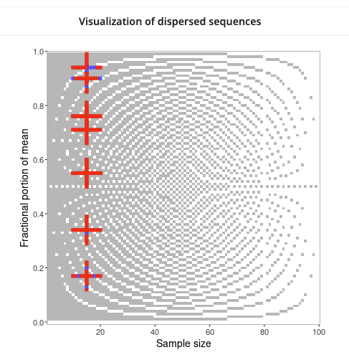

The authors state that “Planned contrasts found that the negative appraisal condition had more intrusions than the benign (p = 0.01), but not the control group (p > 0.05)” (p.110). This non signficiant result is useful, as the effect size included in the Varma et al.’s (2024) meta-analysis would have been highly signficiant at g = 2.7, even at N = 30.

Using Hussey’s {recalc} package and shiny app (https://errors.shinyapps.io/recalc_independent_t_test/), we recalculated hedge’s g from the summary stats under the assumption that the reported SDs are SDs vs mislabelled SEs. This common error in meta-analyses is known as “the Standard Error error”. Assuming SDs, hedges g is roughly 2.69 and highly significant. Assuming SEs, it is approximately g = 0.69 and non significant, better corresponding with the authors’ p value.

Based on this convergent evidence, we therefore conclude that it is likely Cheung & Bryant’s (2017) SDs in their Table 2 are actually SEs.

As such, Varma et al. (2024) should have either included the more plausible effect size of g = .69 (+ correct associated variance, not calculated here) as the appropropriate effect size rather than g = 2.67, or they should have excluded Cheung (2017) as not sufficidently trustworthy to include.

